# User Guide for Image Classification Tool

## Installation

This is a Java Program, in order to run it. You need to have Java 8, IDEA (Most Common JAVA IDE in the world), Maven(Usually installed already in IDEA), and Tomcat 8 installed on your computer.

JAVA: [java.com/zh-CN/download/java8_update.jsp](https://www.java.com/zh-CN/download/java8_update.jsp)

IDEA: https://www.jetbrains.com/zh-cn/idea/

Tomcat: [Apache Tomcat® - Apache Tomcat 8 Software Downloads](https://tomcat.apache.org/download-80.cgi)

## Overview

### Define your working folder in ImageController.java

It should looks like: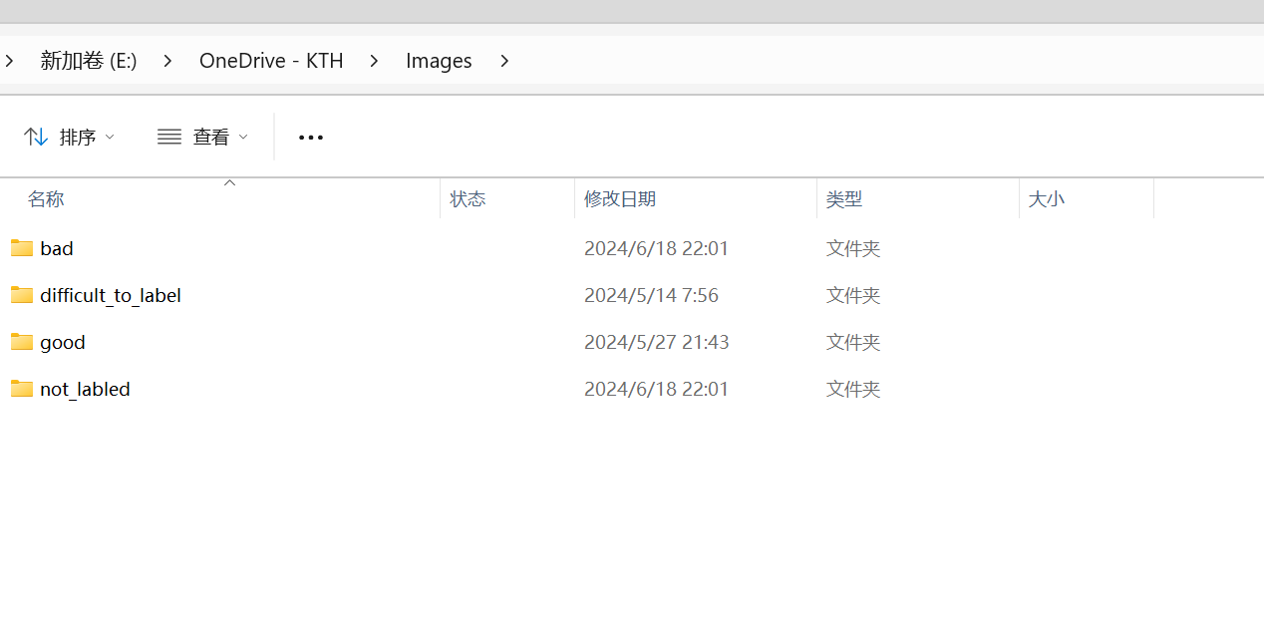

Put unlabeled images into “not_labled”, remember to clear other folders if you don’t want to continue the work. The image will move to the corresponding folder (see folder name) when you classify them.

Better to per-defined the folder before

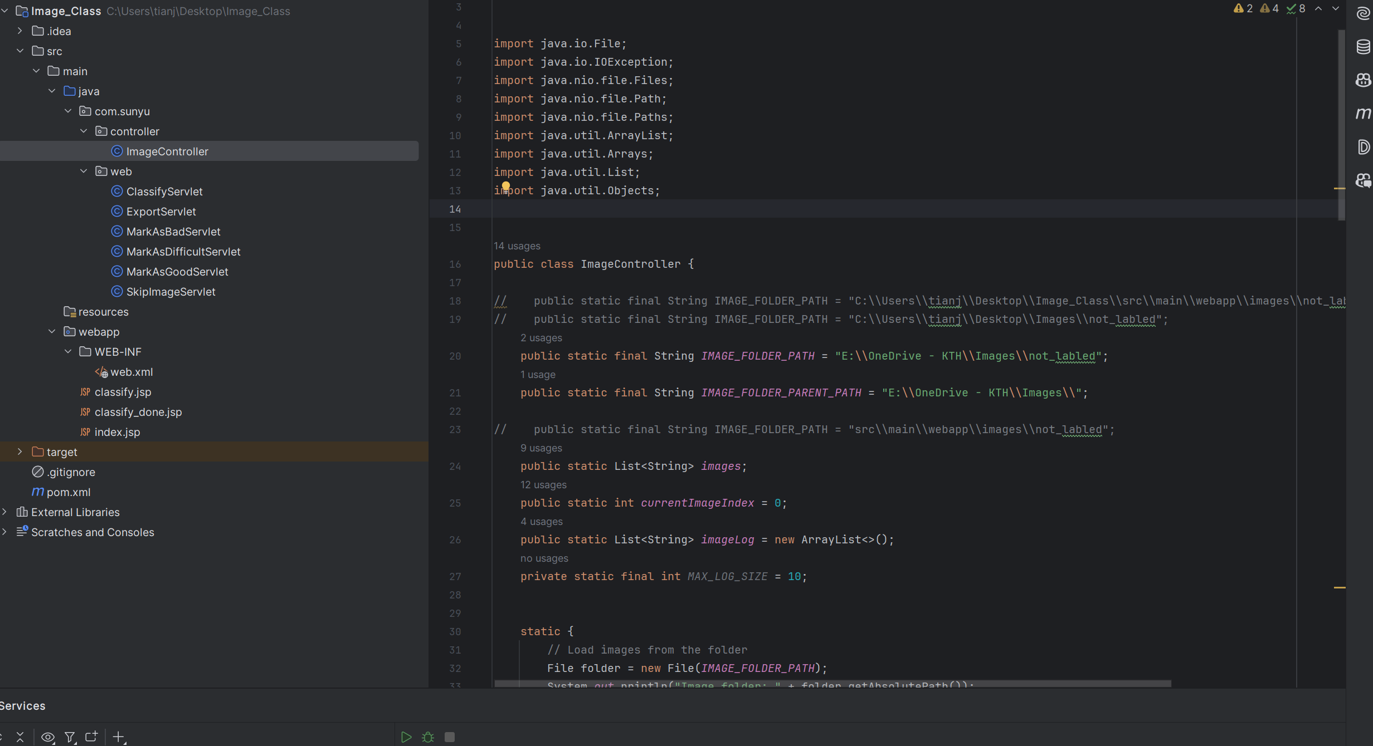

### And Edit configuration:

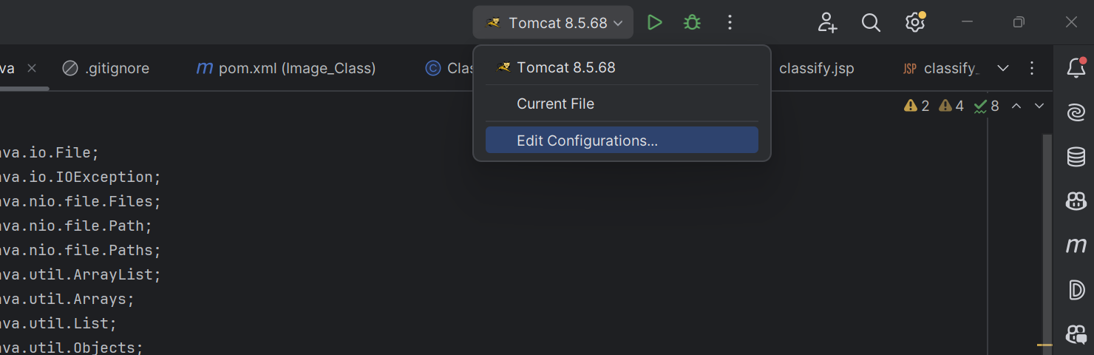

This is my configuration all you need is to add Tomcat as server:

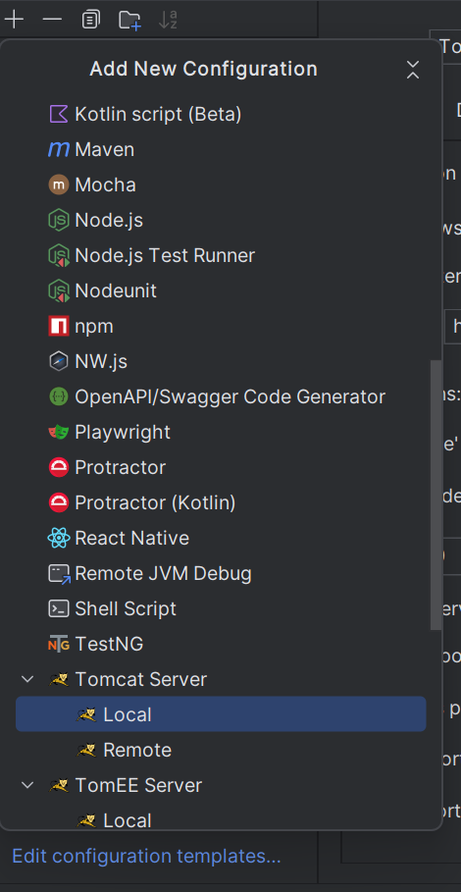

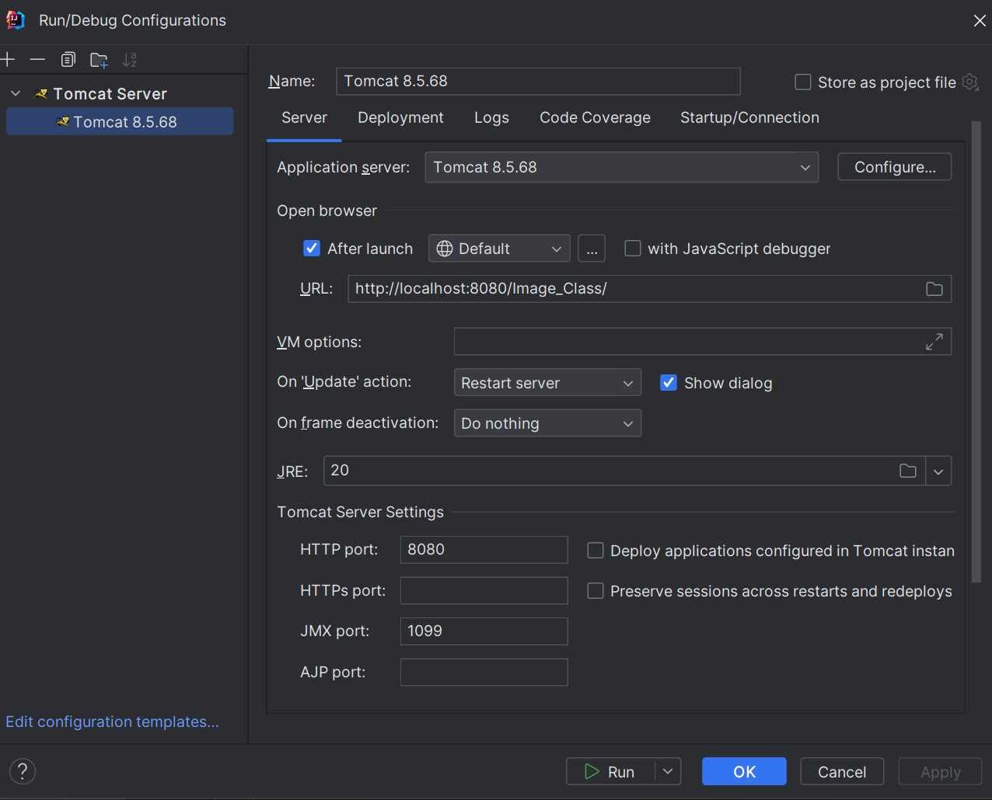

### Running:

Just click this button, then it should start a server on **http://localhost:8080**

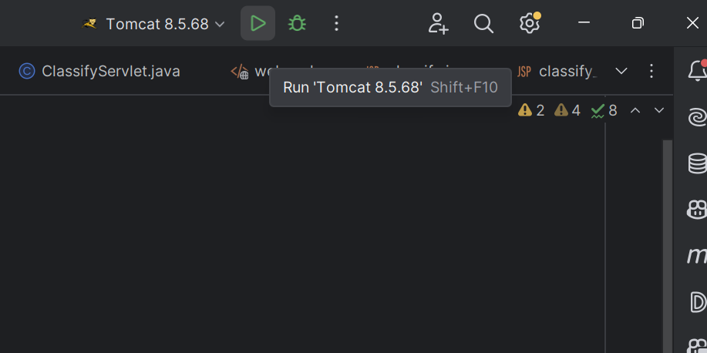

## What it Looks Like:

Get ready for classifying. Click it!

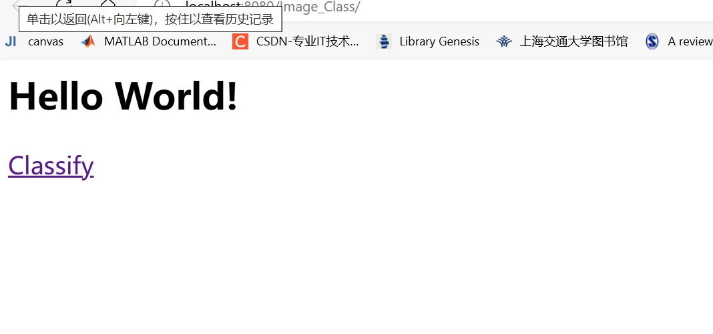

Then you will see a window looks like:

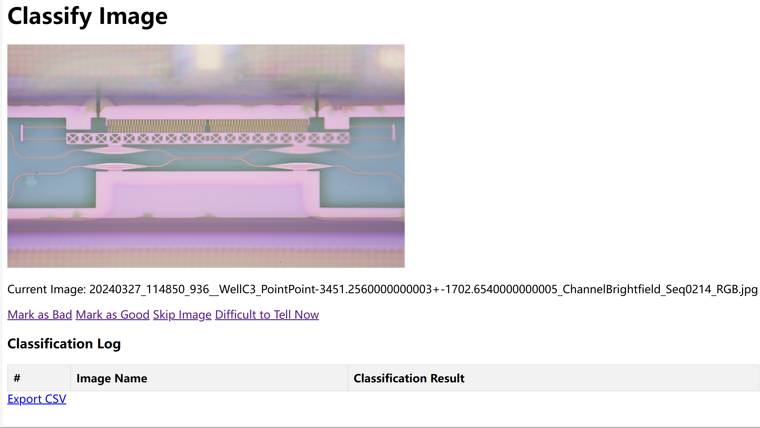

Press “**G”** for good, “**B**” for bad “**S**” for skipping this image now, **“D”** for difficult. And image will move to corresponding folder.



## Log

There’s a classification log here, for you to see latest 10 classification results, you can regret your label by looking at the name, and find it in the result folder.

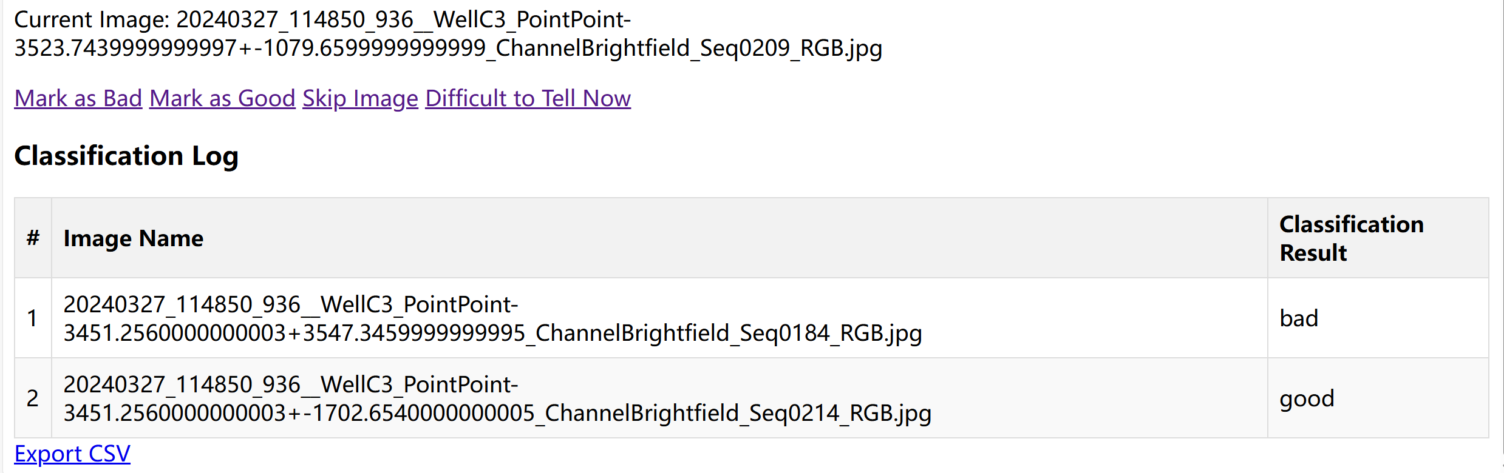

Also, you can **Export CSV** for result if you press the button.